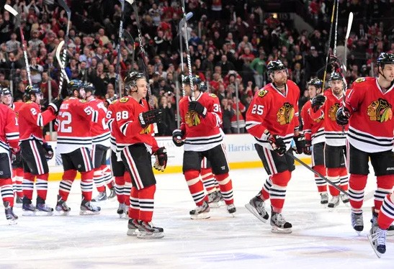

4 SKYBOX SUITE SEATS
including
1 Parking Pass Food & Beverage

Chicago Blackhawks vs
Dallas Stars

Saturday, April 6th, at 3:30pm
$3,500.00 Value
Compliments of

